**DAY 2 [17/01/2022]: Online Vs Offline Learning**

**Above are the types of machine learning based on how the ML model gets trained, especially the production.**

**Production is the server on which the code would be run.**

**1.Batch/ Offline Learning**

**It is the conventional way of training ml model where we use the whole data to train the ml model. There is no incremental training.**

**Generally, the data would be large and if we try to train the large data simultaneously which is not done usually, is time taking and costly.**

**Hence the batch learning where we train the whole data at a time is done offline on our machine. Once the model is trained, this trained model would be passed onto the production environment.**

**We take the entire data, train it in an offline system and then deploy it on to a server.**

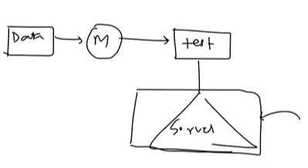

**But the problem is, Model is static. We have to constantly evolve ml model with the data. For example, the movies in Netflix today can’t be the same for tomorrow since new movies would be coming up. Hence the recommendation engine should always grow in order to incorporate new movies. Hence, we need to retrain the model again and again.**

**To solve this problem, they do this process periodically. The new data would be updated regularly for any time interval. Then merge that new data with the old data and again train the model proceeds with testing the model and put it on to the server.**

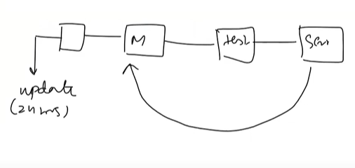

**Since the data is big, we don’t train it online which would result in server down. Instead, pull down the model and retrain it with new data and put it on server again. This happens periodically.**

**Disadvantages:**

**1.Lots of data**

**As the gets bigger and bigger, existing tools won’t be sufficient enough to handle it.**

**2.Hardware Limitation**

**Sometimes the ml model would be running in a place where there is no instant connectivity (no internet). At that time, we won’t be able to retrain the new data.**

**3.Availability**

**Let’s assume demonization has been declared. Now it has to be informed in news immediately. Since in batch learning, model would retrained only in certain interval of time, it cannot declare the news in that instant of time**